General Notes
Double click WINSC03.exe to open SC03
Use File/Quit to exit from SC03
If SC03 fails to load up, try Cntrl/Alt/Del and ending the process
If that fails, try copying the files to a different directory
If that fails log off and then back on again !!

SC03 Training Exercise: 1d – conduction
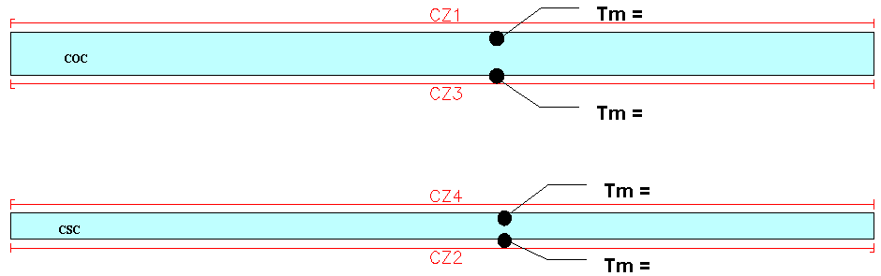
Model: 1dconduction.pm

Instructions:
- Apply the convecting zones given below as shown above using SC03 units as shown below. (Thermal/Convecting Zone)
CONVECTING ZONES
----------------

| INDEX | 1 | INDEX | 2
| FLUID TYPE | air | FLUID TYPE | air
| TEMPERATURE | 440 | TEMPERATURE | 830
| PRESSURE | 0.18 | PRESSURE | 2.870
| HTC | 0.00953 | HTC | 0.860

| INDEX | 3 | INDEX | 4
| FLUID TYPE | air | FLUID TYPE | air
| TEMPERATURE | 700 | TEMPERATURE | 700
| PRESSURE | 1 | PRESSURE | 1
| HTC | 0.2675 | HTC | 0.2675

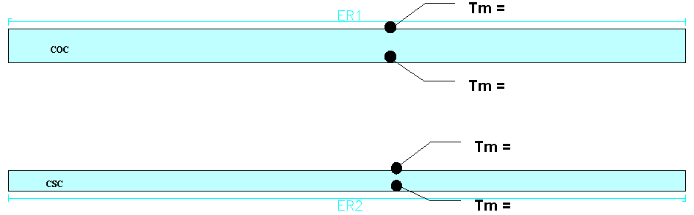
a) Run the model and determine the temperatures at each of the surfaces of the casings. (Use Analysis/Run to run the model, then use Results/Get Values to find metal temperatures – use right-hand-mouse END to come out of the get values command))

- Apply the external radiation given below to the previous model in the locations shown above. (Thermal/External Radiation)

EXTERNAL RADIATION
------------------

| INDEX | 1 | INDEX | 2
| EMISSIVITY | 0.2 | EMISSIVITY | 0.5
| REMOTE TEMP. | 340 | REMOTE TEMP. | 950

b) Run the model and determine what difference radiation makes.

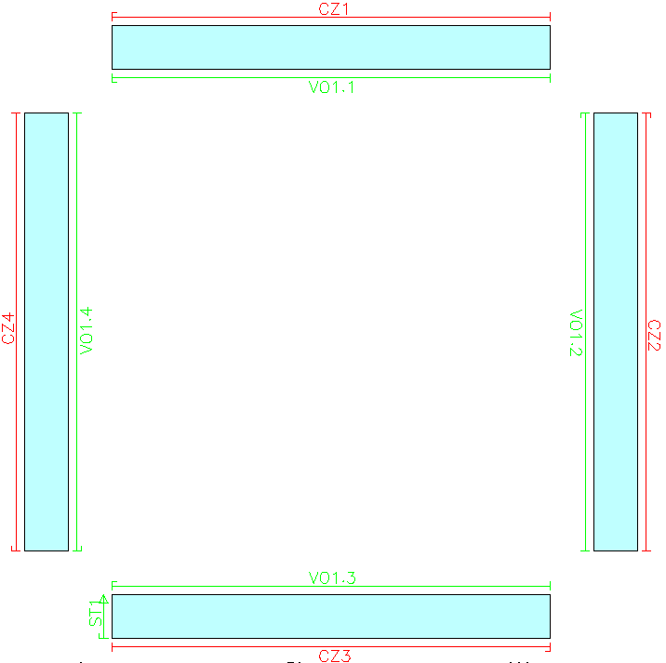
SC03 Training Exercise: Voids
Model: Voids.pm

- 4 user parameters have already been specified for you using Model/User variables):

--------------------------------------------------------------------------------
USER PARAMETERS
--------------------------------------------------------------------------------
T1 = 300
T2 = 510
T3 = 440
T4 = 720
--------------------------------------------------------------------------------
MODEL BOUNDARY CONDITIONS
--------------------------------------------------------------------------------

- Apply boundary conditions to the model as shown above (Use Thermal/Convecting Zones & Thermal/Voids)

CONVECTING ZONES
----------------

| INDEX | 1 | INDEX | 2
| FLUID TYPE | air | FLUID TYPE | air
| TEMPERATURE | T1 | TEMPERATURE | T2
| PRESSURE | 0 | PRESSURE | 0
| HTC | 100 | HTC | 100

| INDEX | 3 | INDEX | 4
| FLUID TYPE | air | FLUID TYPE | air
| TEMPERATURE | T3 | TEMPERATURE | T4
| PRESSURE | 0 | PRESSURE | 0
| HTC | 100 | HTC | 100

PTO
Note: for the voids ensure that the index is always 1 and it is the sub-index that is changed for the 4 sides.

THERMAL VOIDS
-------------

| INDEX | 1 | INDEX | 1
| SUB-INDEX | 1 | SUB-INDEX | 2
| VOLUME | 0 | VOLUME | 0
| FLUID TYPE | air | FLUID TYPE | air
| POWER INPUT | 0 | POWER INPUT | 0
| PRESSURE | 0 | PRESSURE | 0
| HTC | 0.300 | HTC | 0.096
| SWIRL VEL | 0 | SWIRL VEL | 0

| INDEX | 1 | INDEX | 1
| SUB-INDEX | 3 | SUB-INDEX | 4
| VOLUME | 0 | VOLUME | 0
| FLUID TYPE | air | FLUID TYPE | air
| POWER INPUT | 0 | POWER INPUT | 0
| PRESSURE | 0 | PRESSURE | 0
| HTC | 0.156 | HTC | 0.015
| SWIRL VEL | 0 | SWIRL VEL | 0

- Run the model and determine the fluid temperature of the void
(Display/discrete data display – note that the void air temperature is given by vt)

Void Tf =

- Add the stream below as shown in the diagram on the previous page and make the stream the power input for all voids. (In each of the 4 voids, make the power input = pwr(1))

| INDEX | 1
| FLUID TYPE | air
| MASS FLOW | 0.0001
| INLET TEMP. | 600
| HEAT PICKUP | 0
| PRESSURE | 0
| HTC | 0
| SWIRL VEL | 0
| FLOW VECTOR | S

b) Run the model, determine, and understand why this stream has the effect on the void temperature that it does.

Void Tf =

SC03 Training Exercise: Streams

Model: advection.pm

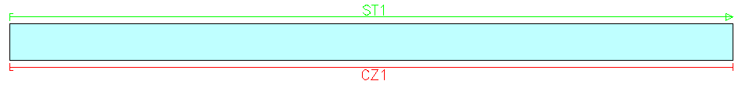
- Apply the given User Parameters and Boundary conditions to the model as shown above

CONVECTING ZONES
----------------

| INDEX | 1
| FLUID TYPE | air
| TEMPERATURE | 800
| PRESSURE | 1
| HTC | 5

STREAMS
-------

| INDEX | 1
| FLUID TYPE | air
| MASS FLOW | 1e-4
| INLET TEMP. | 400
| HEAT PICKUP | 0
| PRESSURE | 0
| HTC | 0.2
| SWIRL VEL | 0
| FLOW VECTOR | S

  - Run the model and determine the temperture rise of the stream (Hint: Use Discrete Data Display – st denotes the stream exit temperature and si the inlet temperature)

Tin =

Tout =
ΔT =

  - Keeping the mass flow of the stream constant at 0.1kg/s (0.0001 Mg/s!) , vary the htc of the stream between 0.1 & 3 (mW/mm²K) and plot a graph of the exit temperature of the stream against htc.

With the stream mass flow fixed at 0.0001Mg/s
htc (mW/mm²K) | Stream Exit Temp (K)
0.01
0.1
0.3
0.6
1.0
3.0

  - Keeping the stream htc constant at 0.2mW/mm²K, vary the mass flow between 1E-5 Mg/s and 1E-2 Mg/s and plot a graph of the exit temperature of the stream against Massflow.

With the stream htc fixed at 0.2mW/mm²K
Mass flow (Mg/s) | Stream Exit Temp (K)
1E-5
5E-5
1E-4
4E-4
1E-3
1E-2

SC03 Training Exercise: Conductance (Thermal Contact)

Model: joint.pm

Run the model with varying values of conductance by modifying the values in the Thermal Contact boundary condition as follows:

Use Thermal/Thermal Contact and change the index down to index 2 (it should say that this already exists)

- For NO CONDUCTION, the perfect conduction toggle should be OFF and the conductance set to 0

- For PERFECT CONDUCTION, the perfect conduction toggle should be ON - the conductance value is ignored

- For PARTIAL CONDUCTION, the perfect conduction toggle should be OFF and the conductance set to the appropriate value

Conductance (mW/mm²K) | toggle | Metal temperature to left of interface (K) | Metal temperature to right of interface (K)
0 (no conduction) | OFF
0.1 | OFF
0.2 | OFF
0.5 | OFF
1 | OFF
2 | OFF
5 | OFF
10 | OFF
perfect conduction | ON

  - Plot a graph of domain temperature against conductance

SC03 Training Exercise: Windage

Model: windage.pm
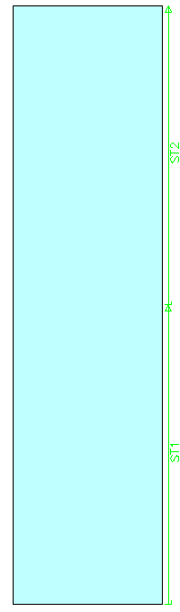

Note: Need to remove steady-state toggle in Model/Global Control/Thermal Control

- Apply the streams given below to the model as shown using SC03 units!

| INDEX | 1
| FLUID TYPE | air
| MASS FLOW | 0.0007
| INLET TEMP. | 400
| HEAT PICKUP | NFDH(NH)
| PRESSURE | 1
| HTC | 0
| SWIRL VEL | 0
| FLOW VECTOR | S

| INDEX | 2
| FLUID TYPE | air
| MASS FLOW | 0.0007
| INLET TEMP. | 400
| HEAT PICKUP | NFDH(NH)
| PRESSURE | 1
| HTC | 0
| SWIRL VEL | 0
| FLOW VECTOR | S

- Run the model and determine the temperature rise due to windage in each of the two streams. (Hint: use Discrete Data Display to determine the temperature rise)
  - Which stream has the largest temperature rise and why?

- Vary the stream mass flows and determine temperature rise for each case.
(Hint: query the boundary conditions and alter the mass flow)
Mass flow | Temp rise
0.0001
0.0002
0.0005
0.001
0.005
b) Plot a graph of Temperature rise against Mass Flow using MSExcel if possible

- With the Mass flow at 0.007Mg/s vary the disc rotational speed (NH – Model/User variables) and determine temperature rise for each case.
NH | Temp rise
100
500
1000
2000
3000
c) Plot a graph of Temperature rise against NH using MSExcel if possible
- Which has the greatest effect?

